- Launch the PremierScribe Professional App. 
- The application will open to the Draft Folder view, this is the ‘home’ page.
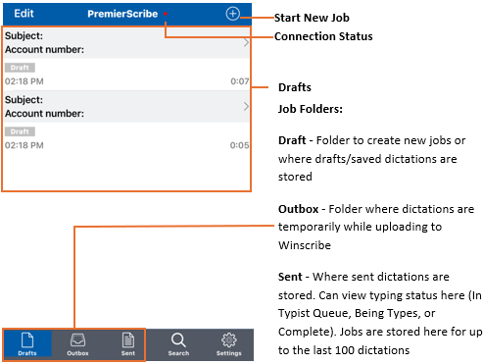
- Click the Start new Job icon in the upper right corner of the Drafts page. It will bring you 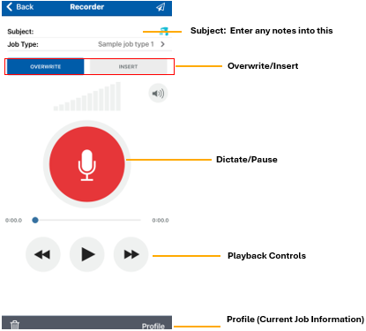
- Click the Record button and Dictate. Then Press the Send button in the upper right corner when finished to send dictation to transcription queue. Confirm by pressing Send Current Job.
iPhone:
- Download app from App Store for iTunes or Google Play Store
- Open Application, click on the Settings
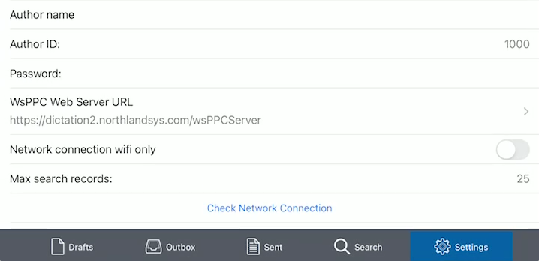

- Scroll down to Author ID and Password. Enter in Author ID and PW
- Then Click in PremierScribe Web Server URL and update to the following:
https://dictation2.northlandsys.com/wsppcserver
- Click on Network Connection and slide switch to the left so it is no longer Green (Unless only want dictations sent when connected to a WiFi spot)
- Click on Check Network Connection Should will state successful

- The Connection Status referenced above should be Green to indicate a connection is established to server. If Red, no connection.
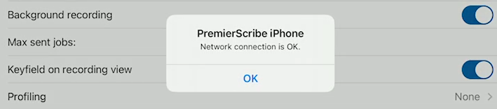
Below are the list of settings within the PremierScribe Professional app for iPhone. We also have listed the suggested settings to Enable that are disabled by default.
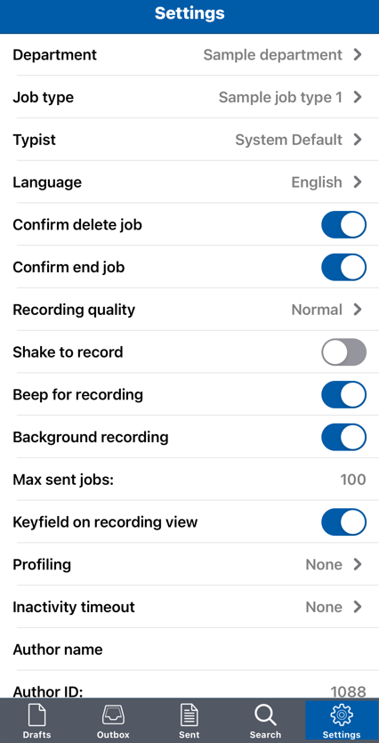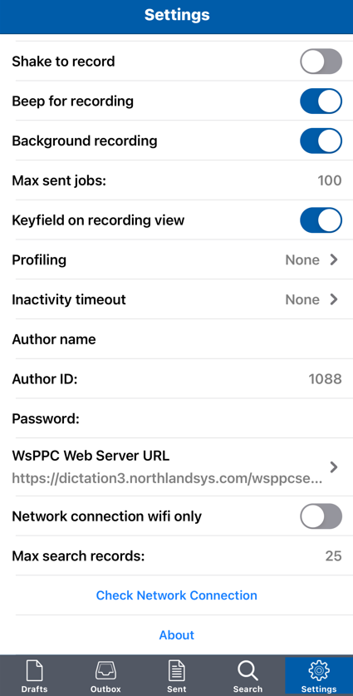
Network connection wifi only – This is Enabled by default, toggle over to disable so it can connect via data plan AND wifi if connected to a hotspot.
Profiling – This opens a meta data window for data entry either before creating a dictation or after depending on the selection. It is disabled by default.
Keyfield on recording view – Enable this setting to see the custom user field to enter data for job. It will display at the top of a new job. Example: Case # or MRN #
Background Recording – Enable this setting so phone can be locked and continue recording while locked and screen off as well as it will record while other apps are in use and PremierScribe is in the background.

